CCGC5003

Python Project Phase 2

Suraj Mandal

Venkata Narasimha Vedavyas Muppavarapu

03/20/2023

TO-DO APPLICATION

# Database Design

## Tables and Fields:

|  |  |
| --- | --- |
| **Tables** | **Fields** |
| **Users**: stores user information, such as username, email, password. | id INT(11) ,name VARCHAR(50), email VARCHAR(50), password VARCHAR(255), profile_picture VARCHAR(255), UNIQUE KEY (email) |
| **Messages**: This table will store direct messages sent between users. It will include the sender and receiver's user ID, the message content, and the timestamp. | id INT(11), sender_id INT(11), receiver_id INT(11) , content TEXT, timestamp DATETIME |
| **Groups**: This table will store information about each group, including the group name and description. | id INT(11),name VARCHAR(50), description VARCHAR(255) |
| **Groups Members**: This table stores the user's task groups, including task group ID, user ID, task group name, and description. | id INT(11), group_id INT(11), user_id INT(11) |
| **Announcements:** This table will store announcements created by admins. It will include the announcement content and the timestamp. | id INT(11) ,content TEXT , timestamp DATETIME |

## Tables and Usage

|  |  |
| --- | --- |
| **Table** | **Usage** |
| Users | This table will store user information, including their name, email, password and date of birth. |
| Messages | This table will store direct messages sent between users. It will include the sender and receiver's user ID, the message content, and the timestamp. |
| Groups | This table will store information about each group, including the group name and description. |
| Group Members | This table will store the relationship between groups and their members. It will include the group ID |
| Announcements | This table will store announcements created by admins. It will include the announcement content and the timestamp. |

An SQL script is created as below for each table with necessary data types as shown below,

-CREATE TABLE Users ( id INT(11) NOT NULL AUTO_INCREMENT,

name VARCHAR(50) NOT NULL,

email VARCHAR(50) NOT NULL,

password VARCHAR(255) NOT NULL,

profile_picture VARCHAR(255),

PRIMARY KEY (id),

UNIQUE KEY (email) );

- CREATE TABLE Messages ( id INT(11) NOT NULL AUTO_INCREMENT,

sender_id INT(11) NOT NULL,

receiver_id INT(11) NOT NULL,

content TEXT NOT NULL,

timestamp DATETIME NOT NULL DEFAULT CURRENT_TIMESTAMP,

PRIMARY KEY (id),

FOREIGN KEY (sender_id) REFERENCES Users(id),

FOREIGN KEY (receiver_id) REFERENCES Users(id) );

-CREATE TABLE Groups ( id INT(11) NOT NULL AUTO_INCREMENT,

name VARCHAR(50) NOT NULL,

description VARCHAR(255) NOT NULL,

PRIMARY KEY (id) );

-CREATE TABLE GroupMembers ( id INT(11) NOT NULL AUTO_INCREMENT,

group_id INT(11) NOT NULL,

user_id INT(11) NOT NULL,

PRIMARY KEY (id),

FOREIGN KEY (group_id) REFERENCES Groups(id),

FOREIGN KEY (user_id) REFERENCES Users(id) );

-CREATE TABLE Announcements ( id INT(11) NOT NULL AUTO_INCREMENT,

content TEXT NOT NULL,

timestamp DATETIME NOT NULL DEFAULT CURRENT_TIMESTAMP, PRIMARY KEY (id) );

## ER-diagram

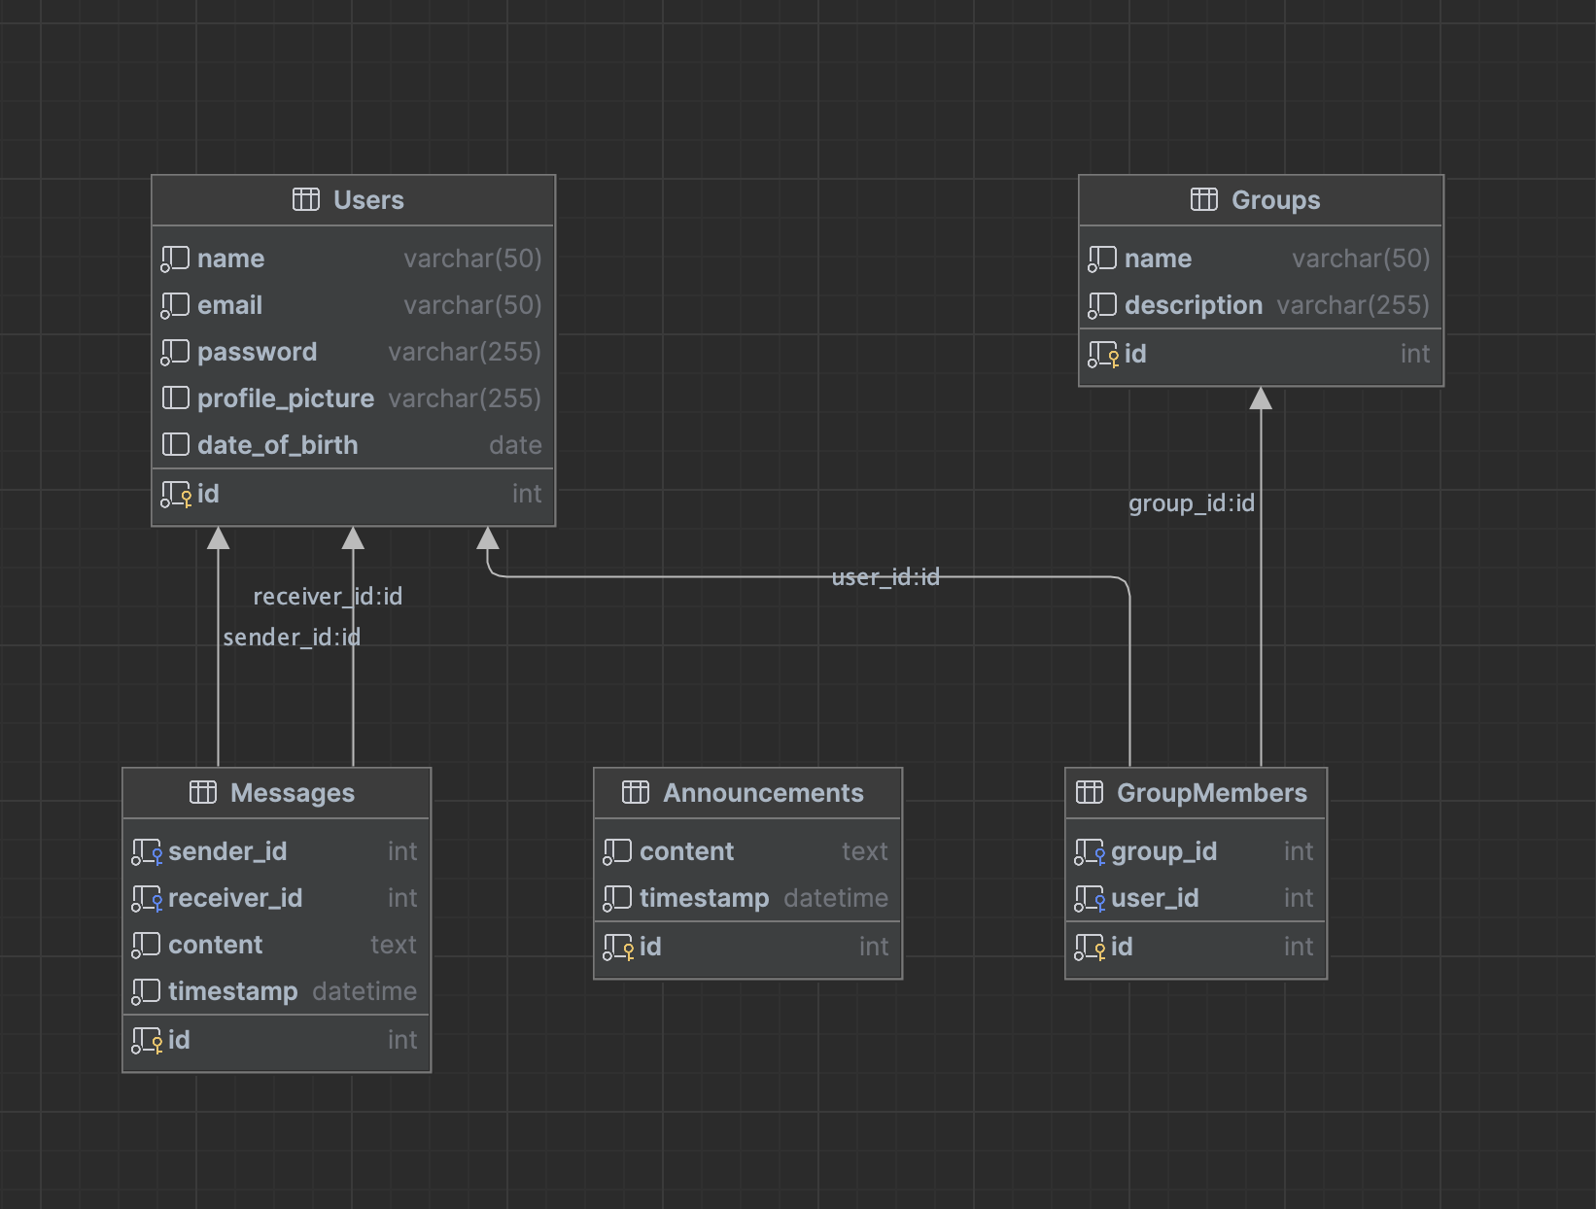

## Firebase with collections as known as tables in relational database.

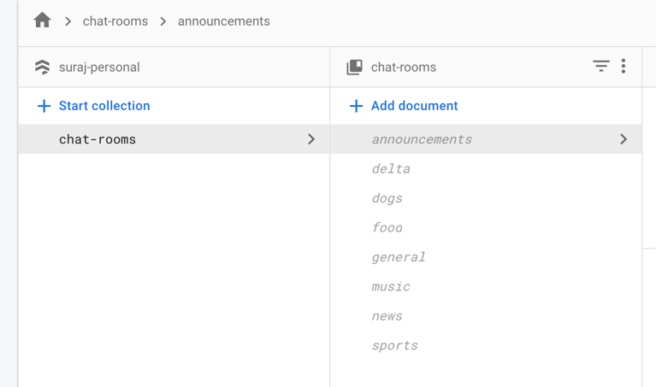

## Test Scenarios with Sample data

The below screenshots show the statements for sample data insertion into the above created tables.

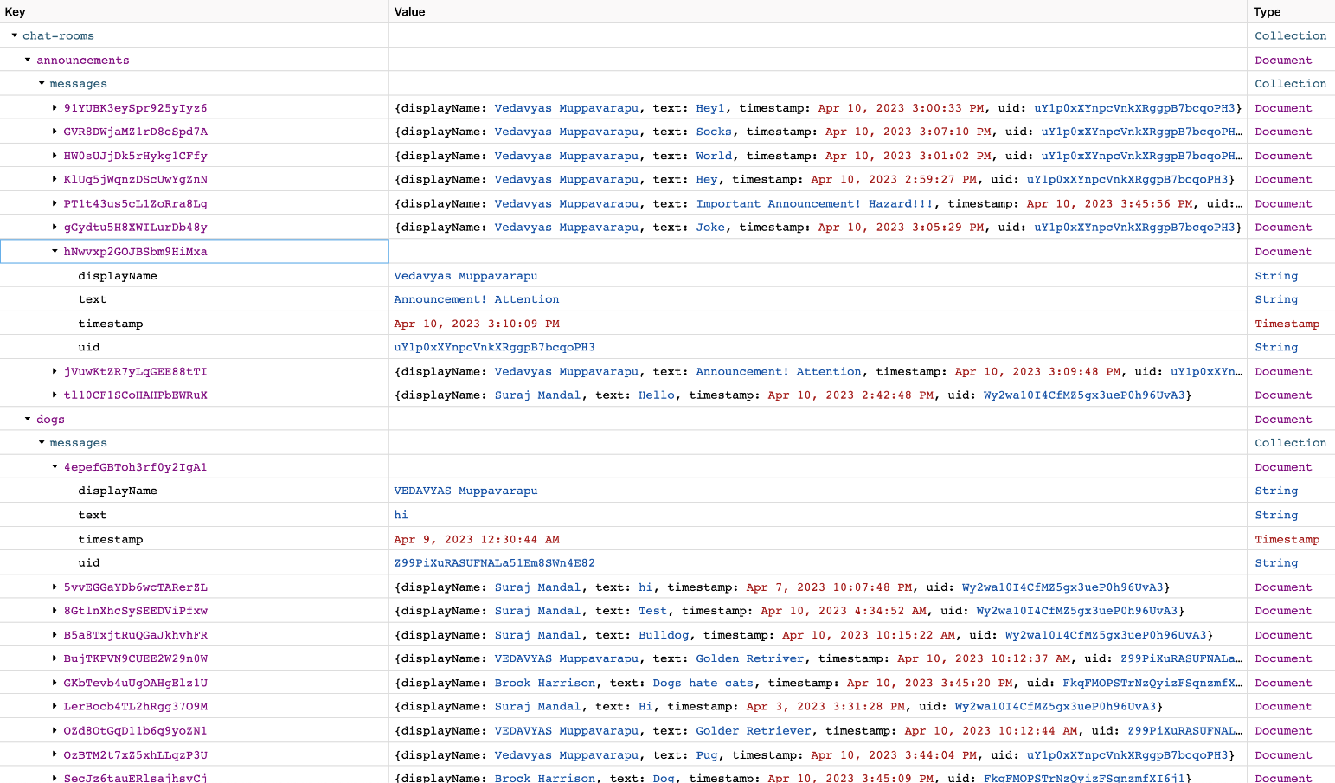

The below screen captures shows the collections after data insertion.

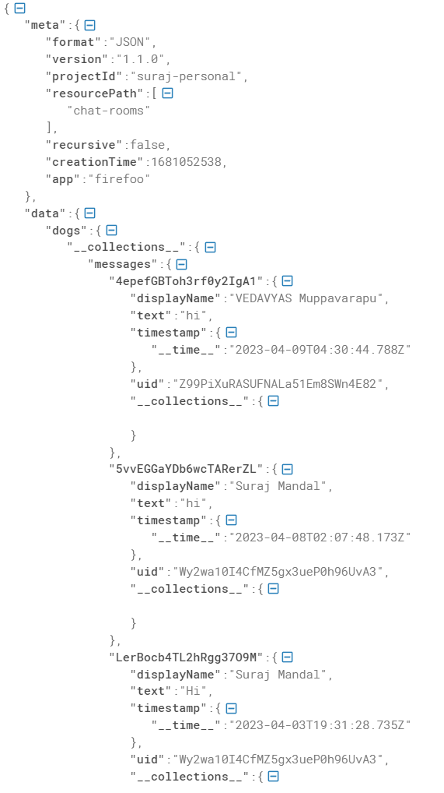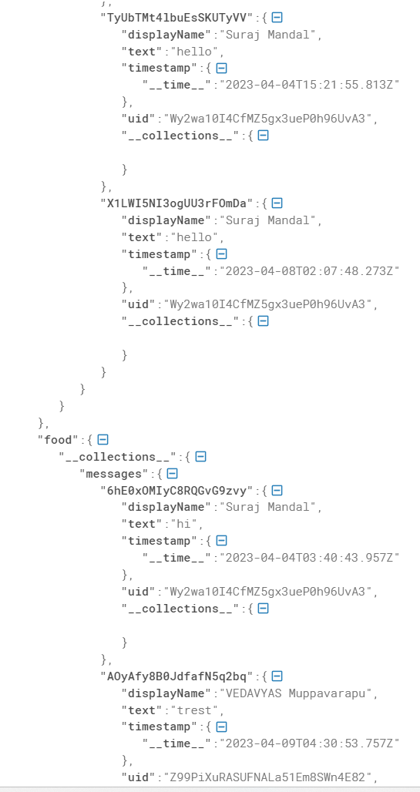

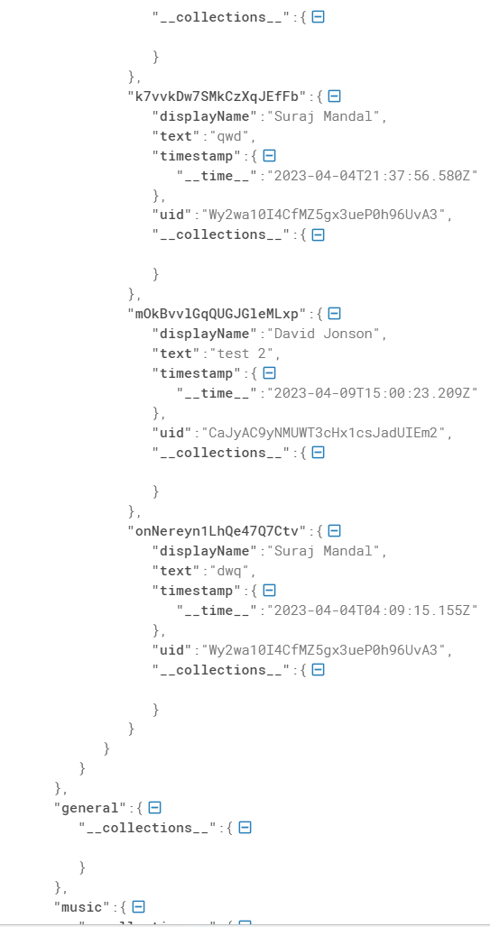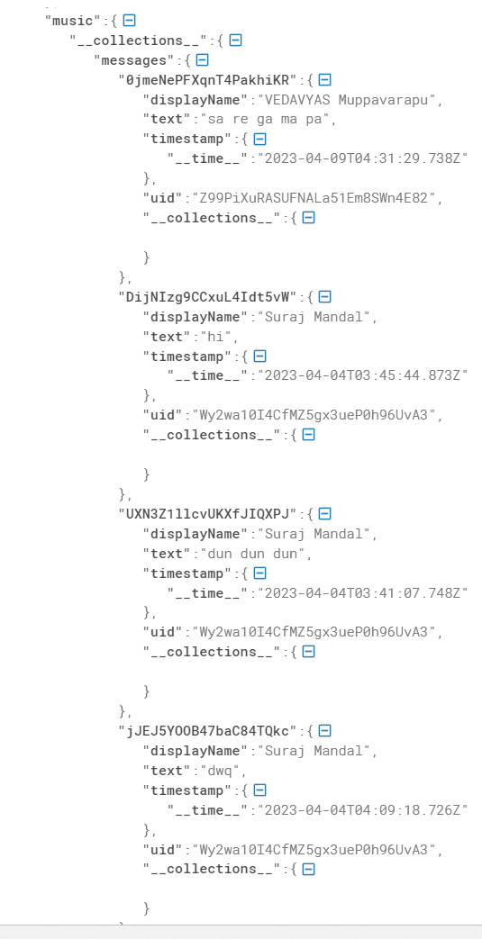

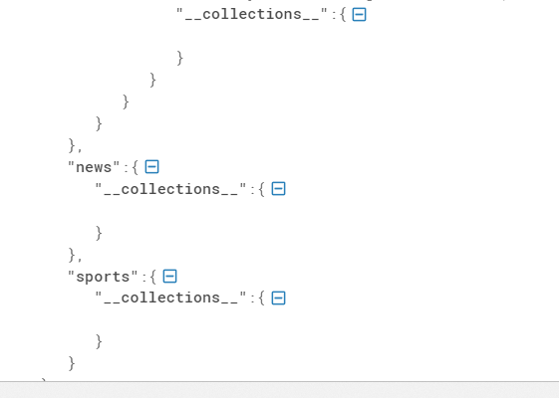

## Test cases for various scenarios

1. User Registration and Login:

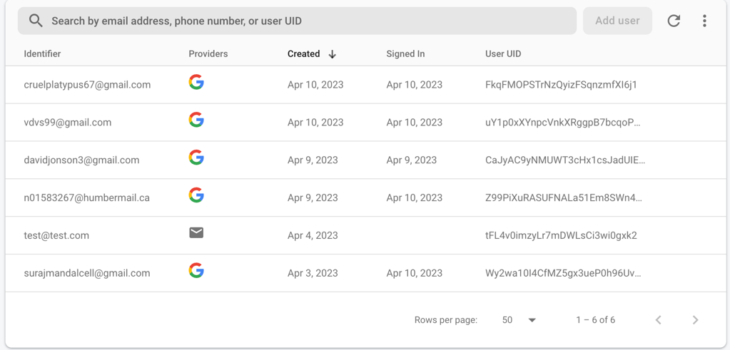

1. announcements screenshot:

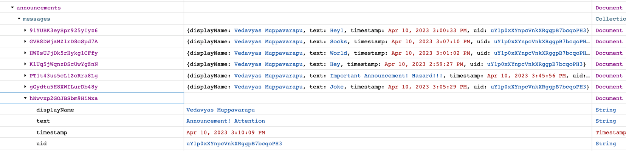

1. Messages for dogs collection:

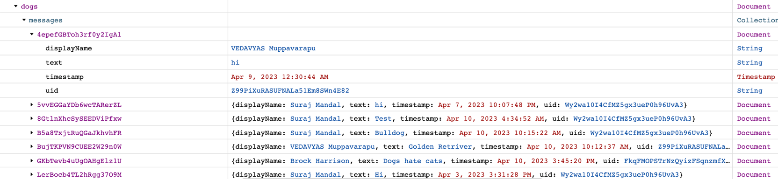

1. Messages for food collection:

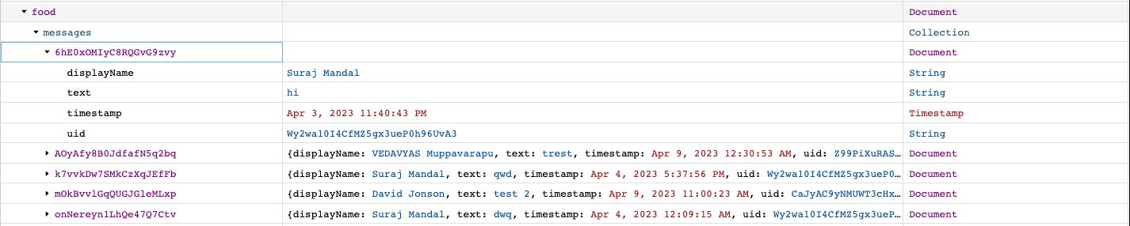

1. Messages for general collection:

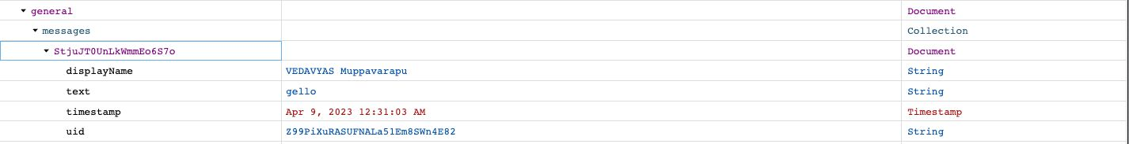

1. Messages for music collection:

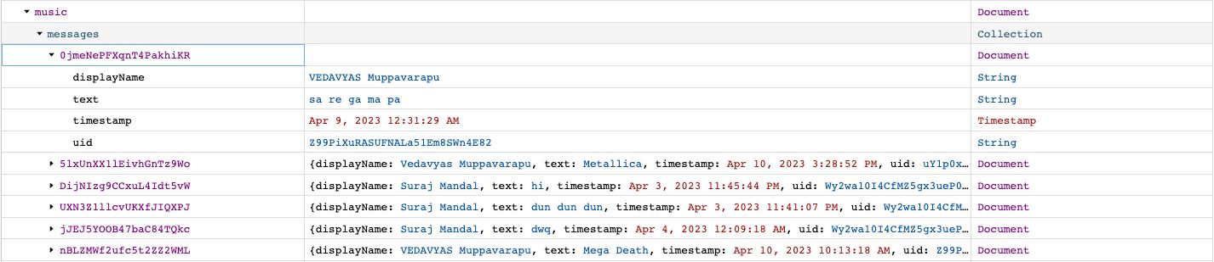

1. Messages for news collection:

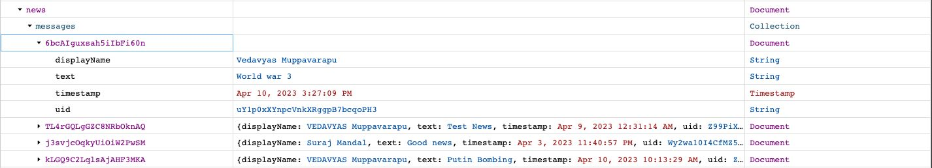

1. Messages for sports collection:

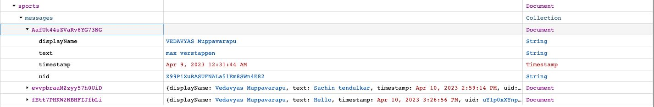

## Team member contribution

**Venkata Narasimha Vedavyas Muppavarapu**

Worked on 3 tables creation, E-R diagram, inserting data to the tables and test case scenarios.

I will be working on project setup and routing integration and implementing the code. Also, will be working on creating UI for foreseeing templates.

**Suraj Mandal**

Worked on 5 tables creation, E-R diagram, inserting data to the tables and test case scenarios.

I will be working on connecting database to the application and testing with multiple scenarios and UI development for login page using HTML.